At about the depth of a little less than 2 meters the temperature stops fluctuating when the surface temperatures fluctuate by about 50 degrees.

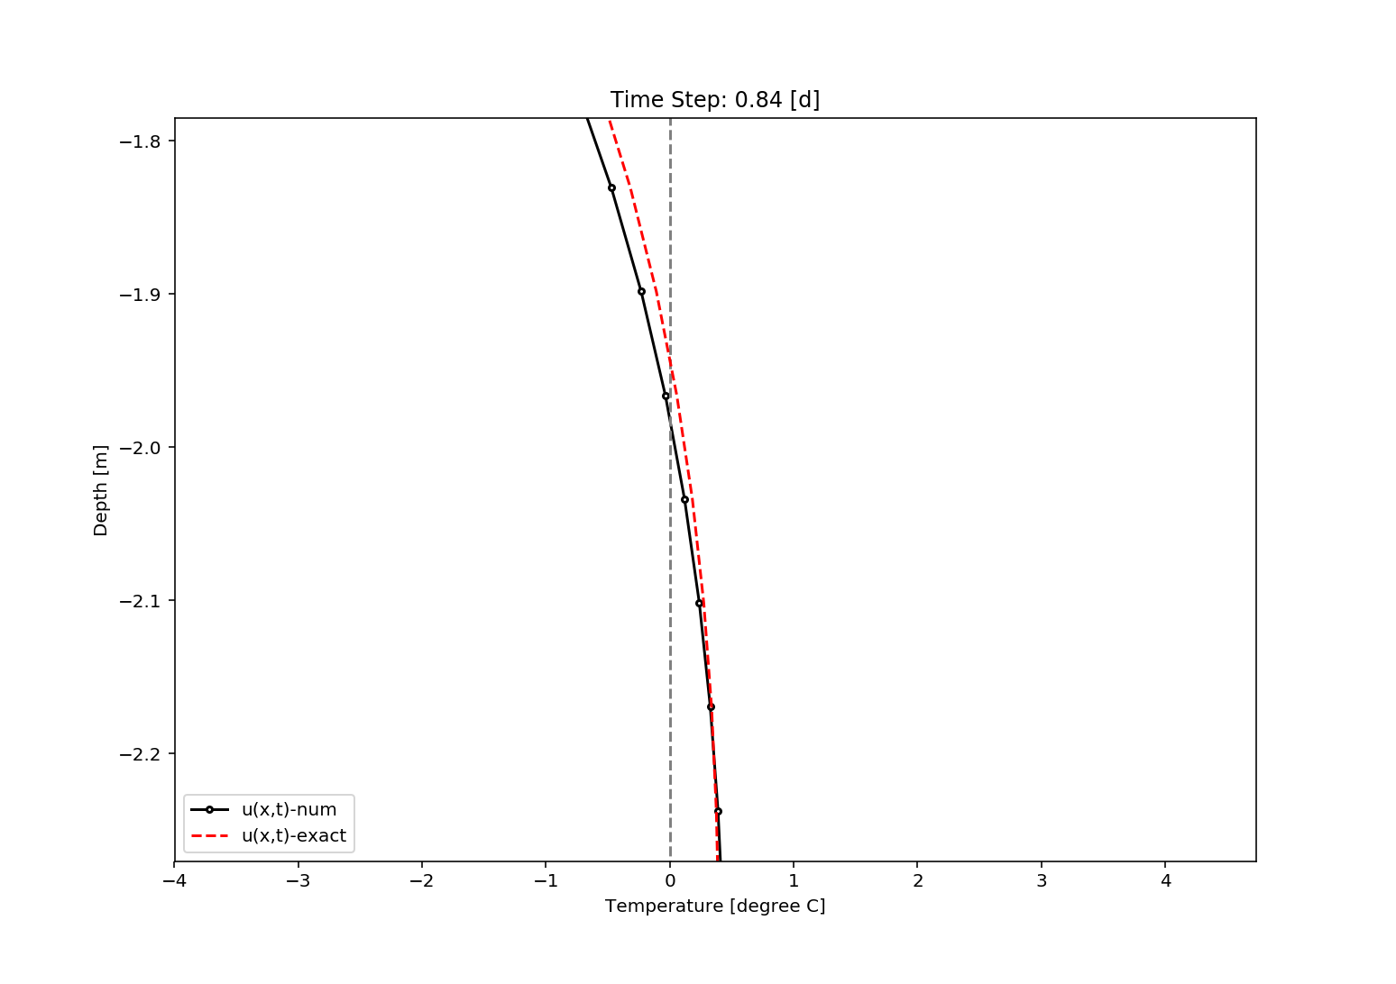

The number solution is slightly off, in the first few days with the exact solution lagging behind the numerical for the first few days. However as time goes on the numerical solution and the analytical solution have similar answers at about 0.75 of the first day.

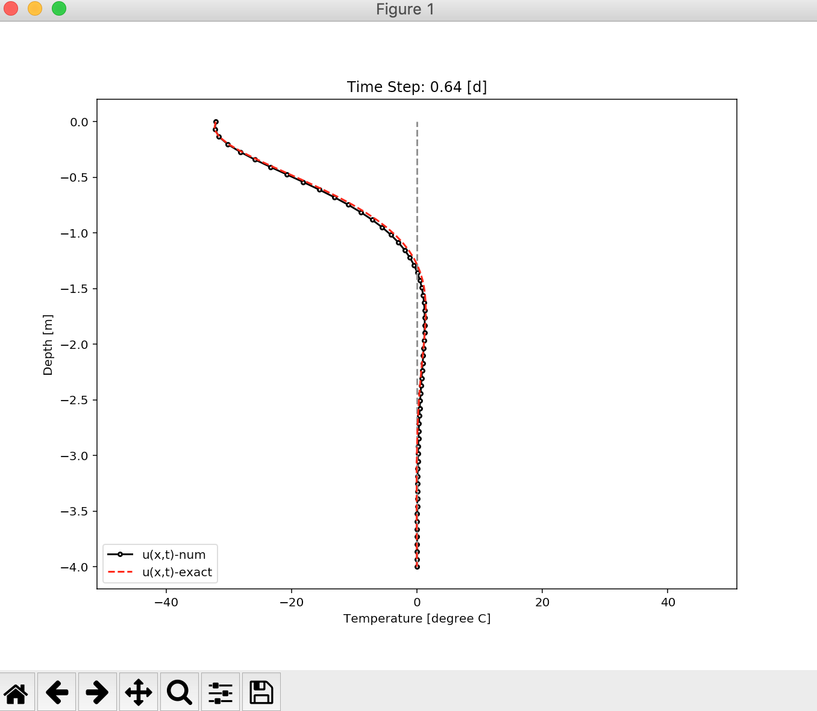

When the surface temperatures fluctuate about 80 degrees we would have to dig to a depth of about 3.3 meters.

